**English Language for Competitive Exams**

**Prof. Aysha Iqbal**

**Department of Humanities and Social Sciences**

**Indian Institute of Technology, Madras**

**Week - 01**

**Lecture – 03**

**Scientific passages and reading comprehension**

Good morning. I hope you are repairing well for whatever exam you are intend to or whichever exam you are trying to take or intend to take. Now we have been talk talking about reading comprehension all this while; the point is that reading comprehension for in competitive exams can be very tricky section. So, far we have done literature, we have done a passage from Henry James, and we have done a few passages last time from novel by Edith Wharton.

Now, but reading comprehension exams they do not always look at works of literature; they nonfiction also it could be politics, it could be environment, it could be any other aspect of science even sports and current affairs. So, from this reading set onwards at least for the next few sets, you will encounter tougher passages not literally passages, these sets are nonfiction passages from different disciplines not just literature. So, unlike fiction passages these are often filled with factual statements and arguments, please remember that you will be tempted to or you may be tempted to answer questions based on your own familiarity with these topics, do not do that please always look at the context.

Remember you read the passage and to answer only the given questions in the context of the passage. It is a good idea, now to start preparing by reading the editorials in newspapers try to read international newspaper and magazines also, this section and I am talking about readings comprehension section in all competitive exams in general, they require not just reading, but analytical skills as well.

(Refer Slide Time: 02:40)

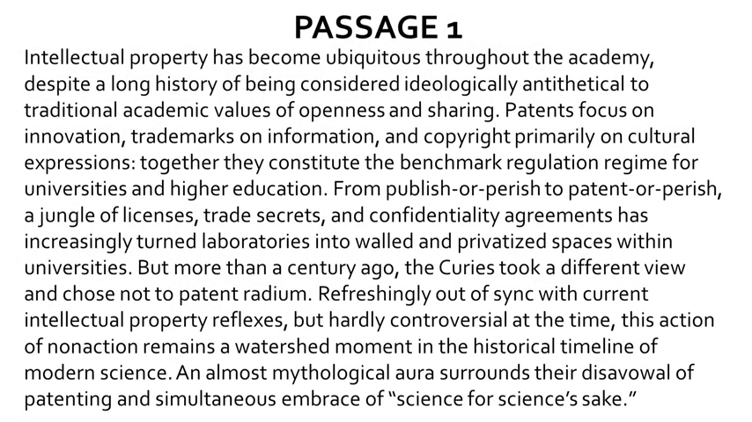

Let us move on to look at the first passage today, please look at the slide.

(Refer Slide Time: 04:11)

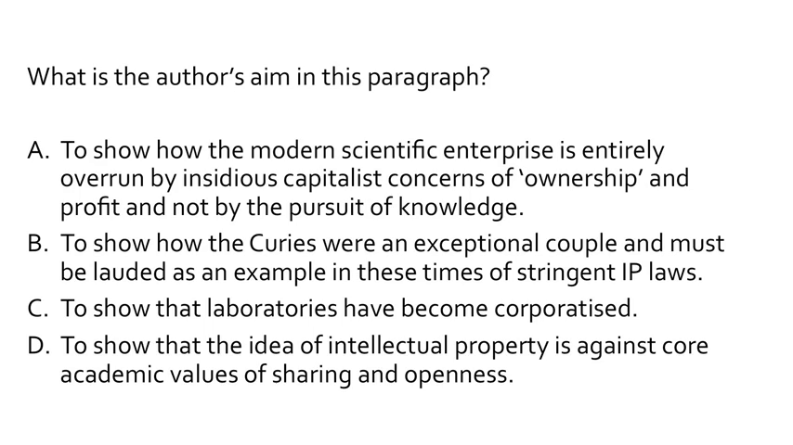

Look at the questions now, what is the authors aim in this paragraph? Option a to show how the modern scientific enterprise is entirely overrun by insidious capitalist concerns of ‘ownership’ and profit and not by the pursuit of knowledge. B; to show how the curies were an exceptional couple and must be lauded as an example in these times of stringent IP laws; to show that laboratories have become corporatized, d to show that the idea of intellectual property is against core academic values of sharing and openness. Please understand all these are very tempting options, anyone can be the correct one however, we have to look at the context and be very precise.

So, the best question response option b, please pay attention to the structure of the paragraph the author begins with the description of the present scenario and then begins another strength of taught with a but; and this is how he starts on the curies. So, we know now that is aim is to contrast the curies work ethic with present in (Refer Time: 05:30) sense the answer is option b; and what is option b? To show how the curies were an exceptional couple and must be lauded as an example in these times of stringent IP laws, please look at the slide again. I know that the option d is extremely tempting, to show that the idea of intellectual property is against core academic values of sharing and openness, where there is just a part of the passages the basic idea the aim is to show how the curies where an exceptional couple, and how they are contrasted with the practises, the corporate practises of patenting and copyrighting in modern times.